**## ------------ WORK-IN-PROGRESS ----------- ##**

# **Alignment/Discussions on Task 4.1**

## **Date:**

11 February 2025

## **Attendees:**

* Tuhfe
* Irene
* Bart
* Wolfram

## **Discussion items**

### **Connections/dependencies with other tasks:**

* Task 3.4 (Demonstration cases)
  + Current discussion ongoing to make parameters/aspects of the different case studies available
    - e.g. end of life actions (life extension, repowering)
    - expected in the coming weeks
    - We expect this to help clarify the problem formulation for optimization
  + case study #2 (Lillgrund)
    - could be a suitable starting example for optimization
  + case study #3 (co-design)
    - potentially to be considered at a later point
* Task 3.1 (Economic impact)
  + Also touches on optimization aspects -> we need to ensure alignment 4.1 <-> 3.1
  + They plan an exercise on Lillgrund (case study #2)
    - should provide insights for optimization
  + Quantization of loads and merging into overall revenue streams
    - ongoing topic, we need to ensure alignment/exchange
* Task 3.2 (societal/environmental impact)
  + qualitative vs. quantitative optimization is clearly a challenge
  + ongoing topic, need to ensure alignment

### **Discussion of scope of 4.1:**

* For now: Focus on operational use cases, i.e. existing wind farm, rather than co-design
  + Lillgrund a very good starting example
    - Assumption: findings made for Lillgrund should be applicable (or easily portable) to other windfarms
* Long-term optimization vs. "real-time" optimization
  + At least for now: focus on long-term
    - Time scale is years rather than days or weeks
    - examples of decision variables
      * down-regulation strategies (see below)
      * repowering
        + increasing overall WF power capacity
        + but also possibility of repowering some and removing other turbines
* The following decision variables were discussed in more detail:
  + Down regulation
    - Note the separation from Task 2.3, which discusses higher-frequency aspects
    - variables in down-regulation:
      * different modes (delta-mode, custom power mode, ...)
      * level of down-regulation (% )
      * ENGIE might be able to provide us with practical insights
  + Repowering
    - Example study: German wind farm (Schkortleben?)
      * master student investigation/survey
      * this wind farm is probably going to be increased in size (WTs added)
        + but some other constraints exist (e.g. height)
  + Cable layout optimization
    - new PhD student working on this at DTU
    - Samuel also working on this?
    - related to IEA systems engineering task

### **General conclusions on guidelines/paradigms for 4.1:**

* Programming language: python
* High flexibility:
  + aim for modular structure
  + it should later be possible to easily exchange modules
* Conceptual structure:
  + Surrogate models considered as one block
  + Metrics evaluation (cost functions) is a separate block
  + There was some unclarity about this during 3.1 presentation, but this has seemingly been resolved

**Questions:**

**Irene:**

*Case studies:*

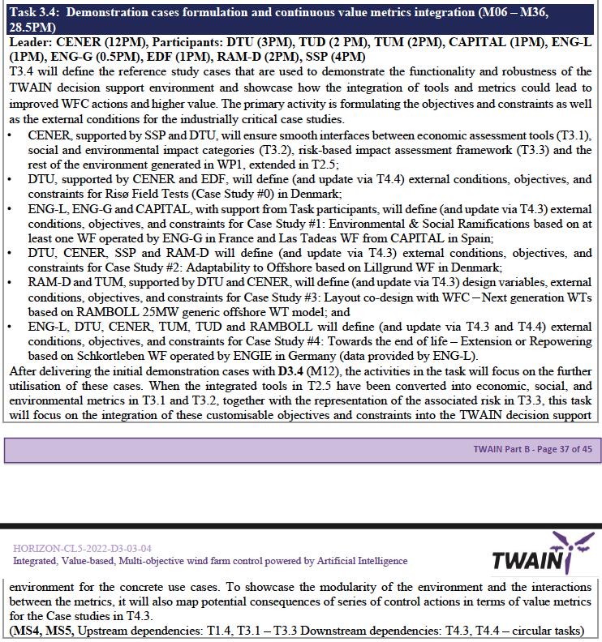

Case study #0: Risø Field Tests for external conditions, objectives, and constraints.

Case study #1: Environmental & Social Ramifications based on at least one WF operated by ENG-G in France and Las Tadeas WF from CAPITAL in Spain.

Case study #2: Adaptability to Offshore based on Lillgrund WF in Denmark.

Case study #3: Layout co-design with WFC Next generation WTs based on RAMBOLL 25MW generic offshore WT model.

Case study #4: Towards the end of life Extension or Repowering based on Schkortleben WF operated by ENGIE in Germany.

*Overview of functionalities:*

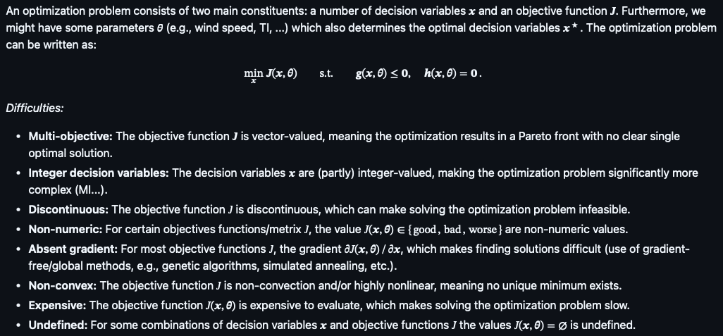

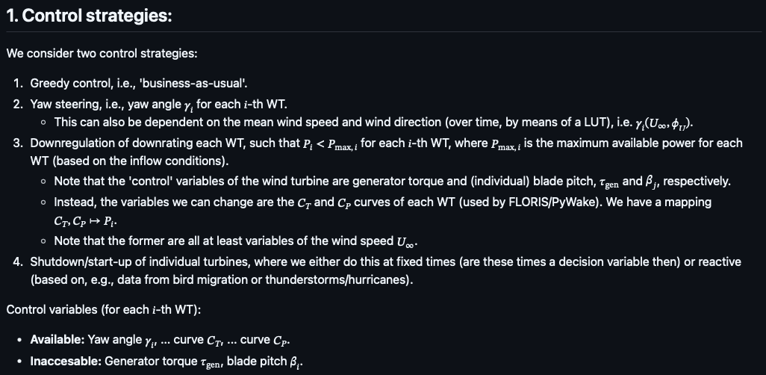

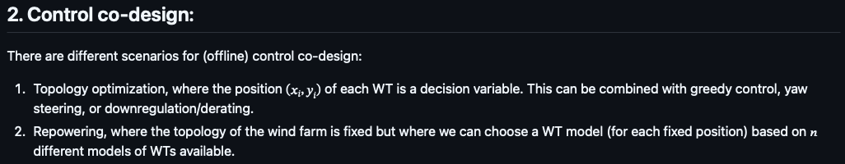

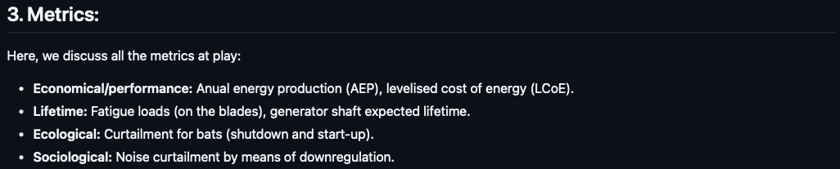

* Repowering: do we have the correct scenario in mind?

**Tuhfe:**

* How far should we deviate from FarmConners MATLAB integrated control toolbox, and how should we use it as a first template (i.e., recreate its functionalities)?

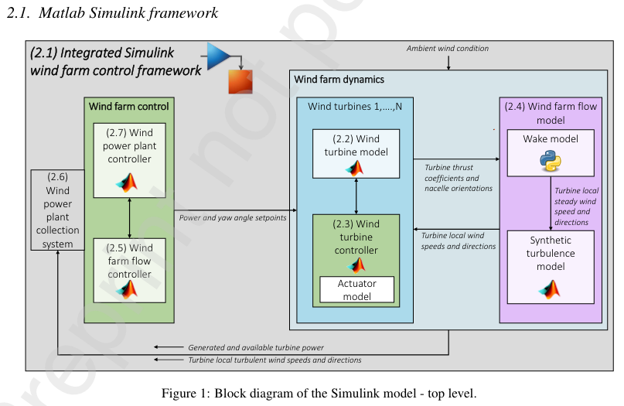

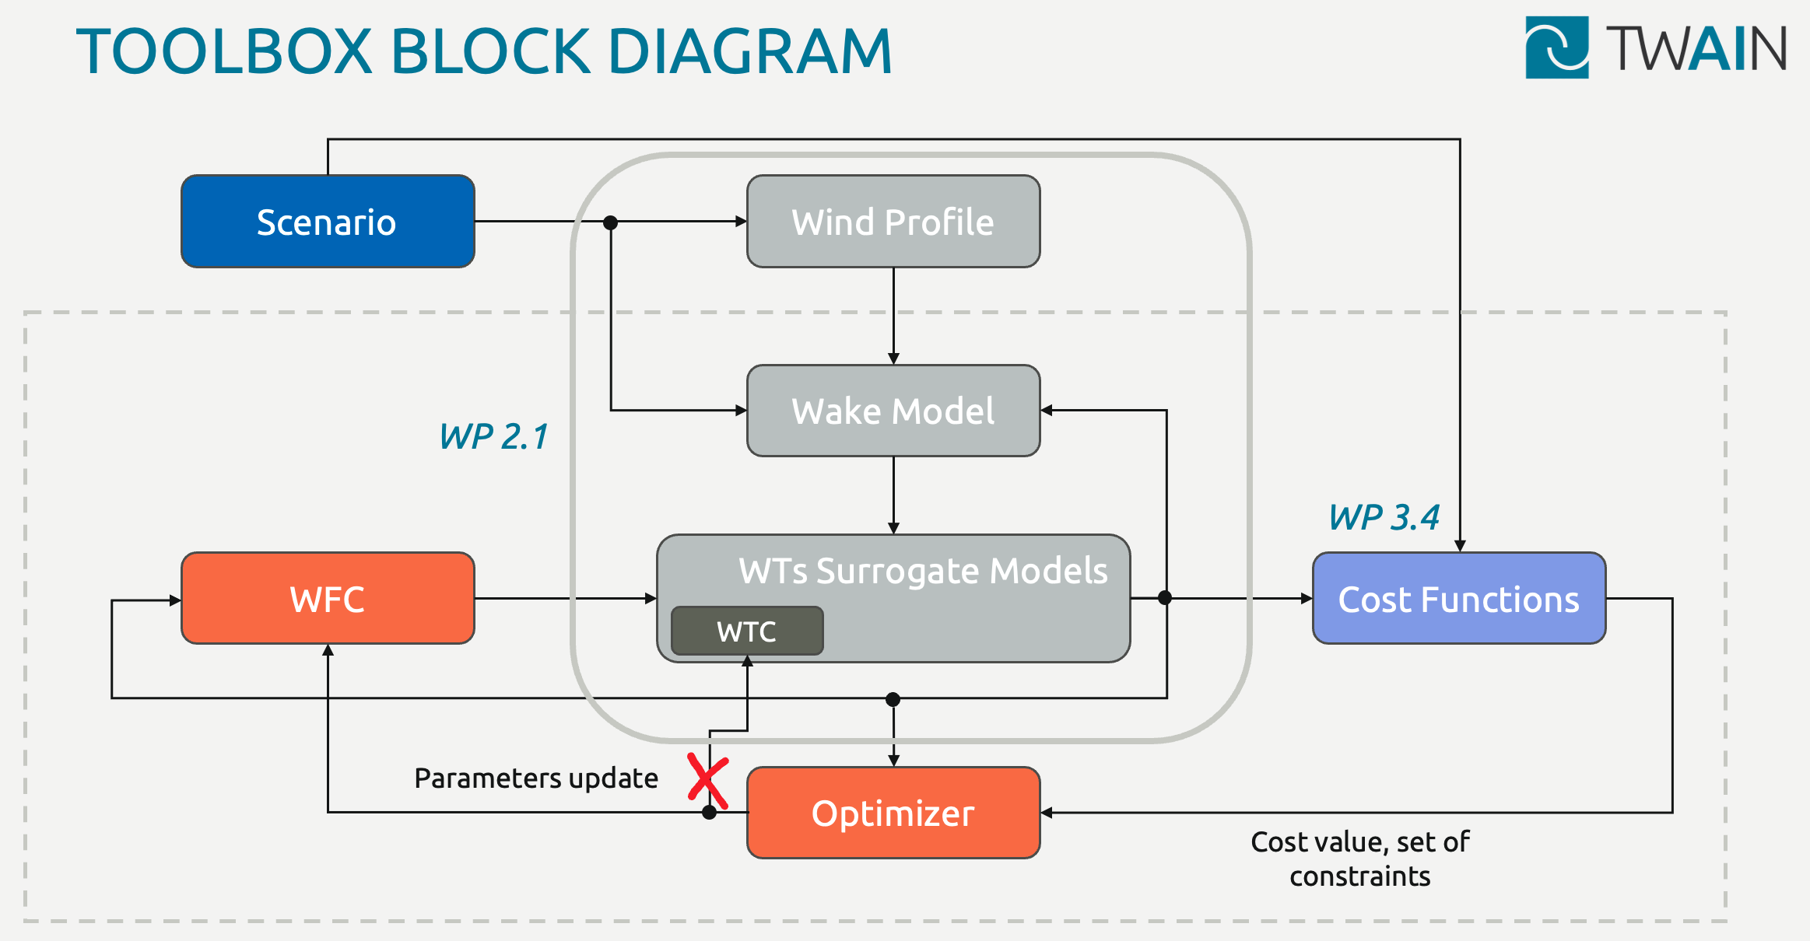

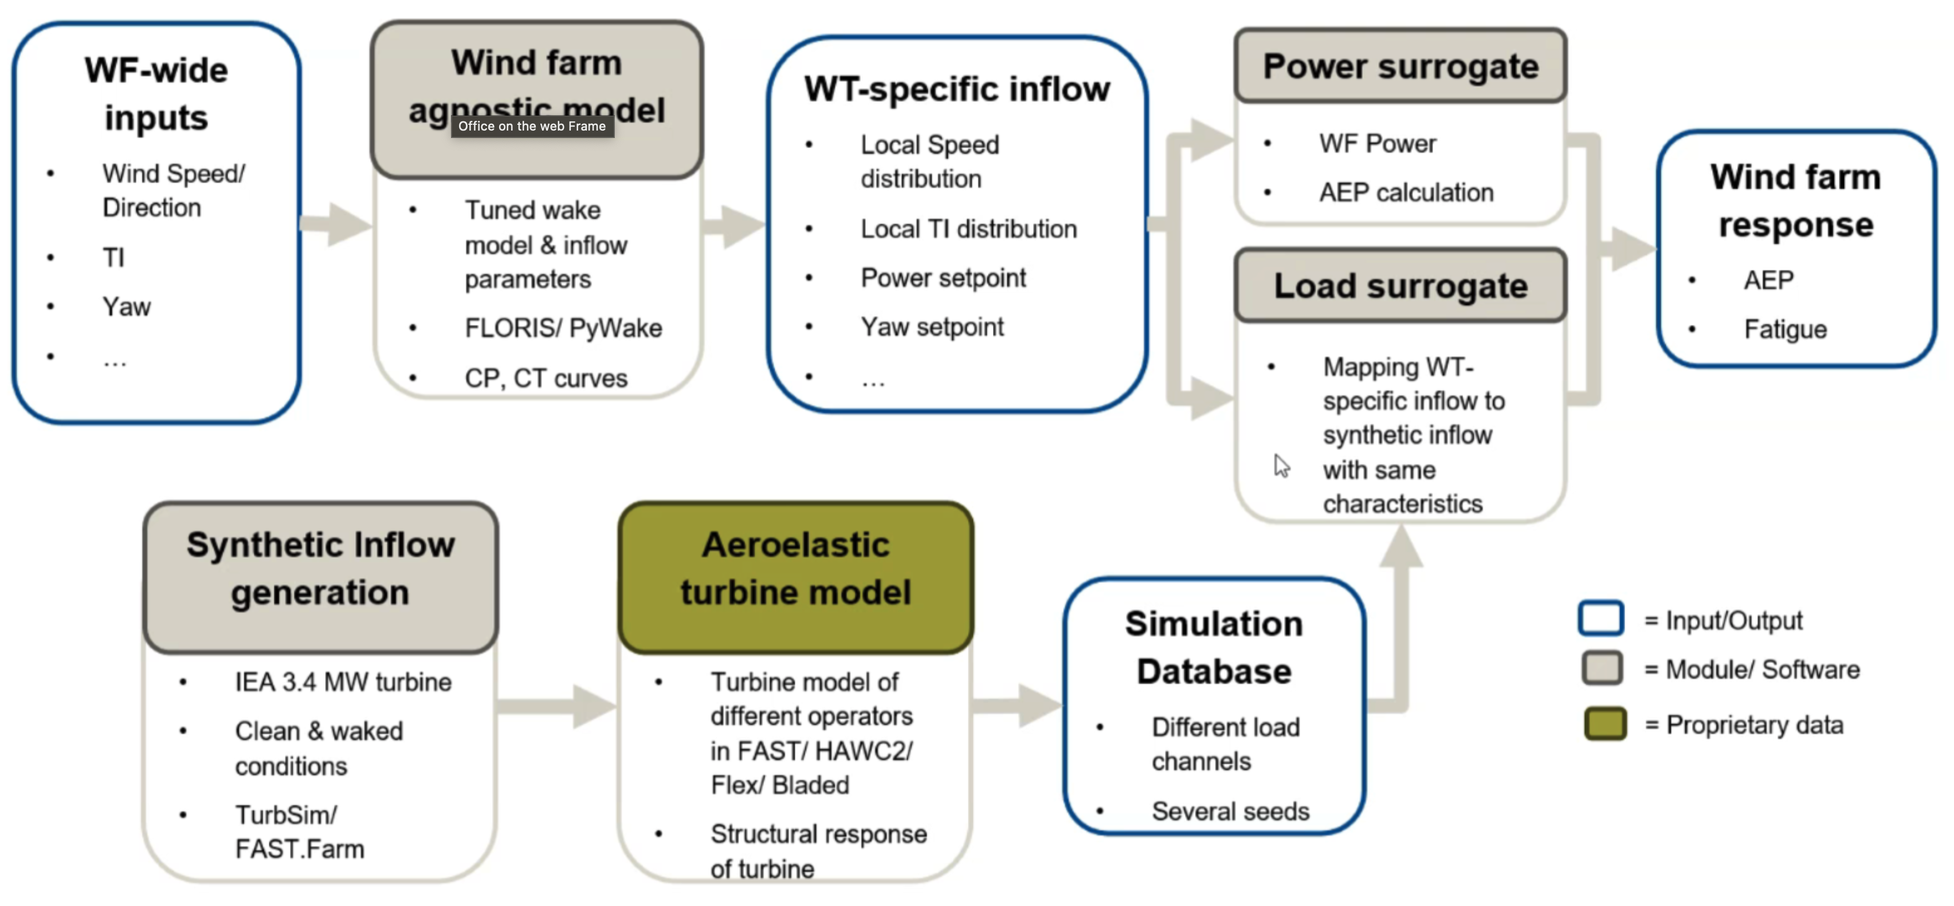

* Is everyone going to make their own framework? Because we were under the impression that there is a ‘separation’ of the ’ wind farm surrogate model and metrics calculation model. So (decision variables, scenario) -> load, power, noise -> LCoE, lifetime, AEP, bat prevention.
* Integration of static data, and relation to TWAIN decision support environment.
* Computation of (sub)optimal reference points.

